**Networking:**

Communication b/w two object is networking [wire or wireless]

But we need common languate to communicate so that is the reason we need binary langauge b/w systems

So that is why ISO developed the OSI model through which every device communicates

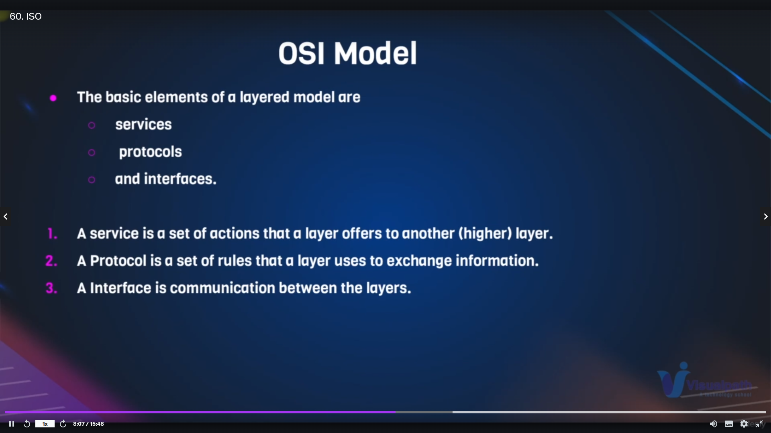

Sevices means that funtion of sendiing data

Protocols means rules

Inteface means connection b/w two layers

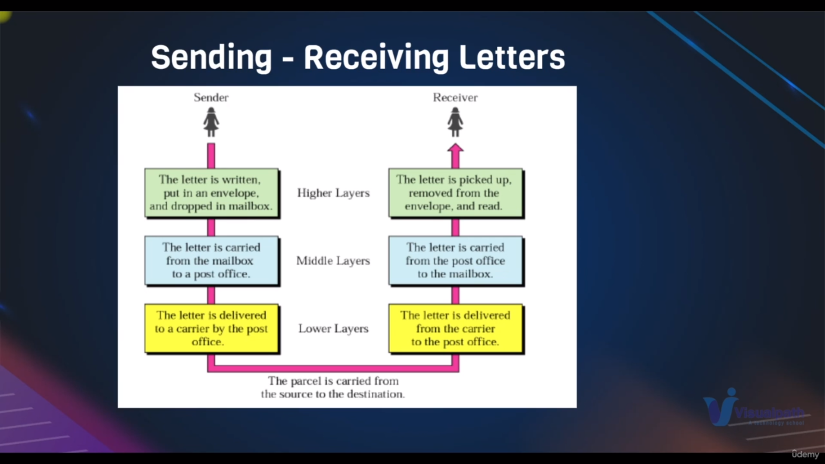

Example for OSI modelExample for osi model

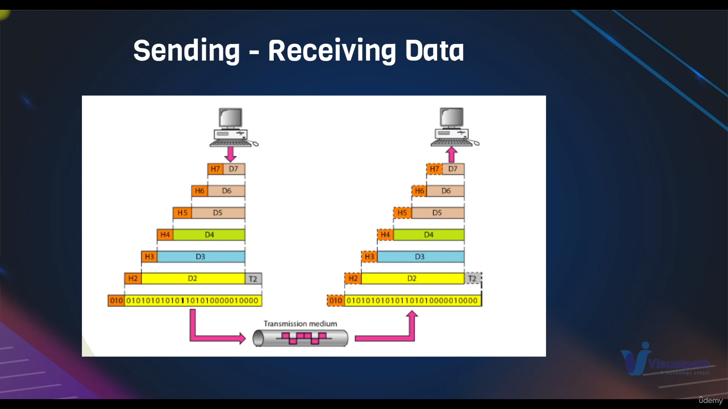

Highlevel view of sending mail from one device to another device

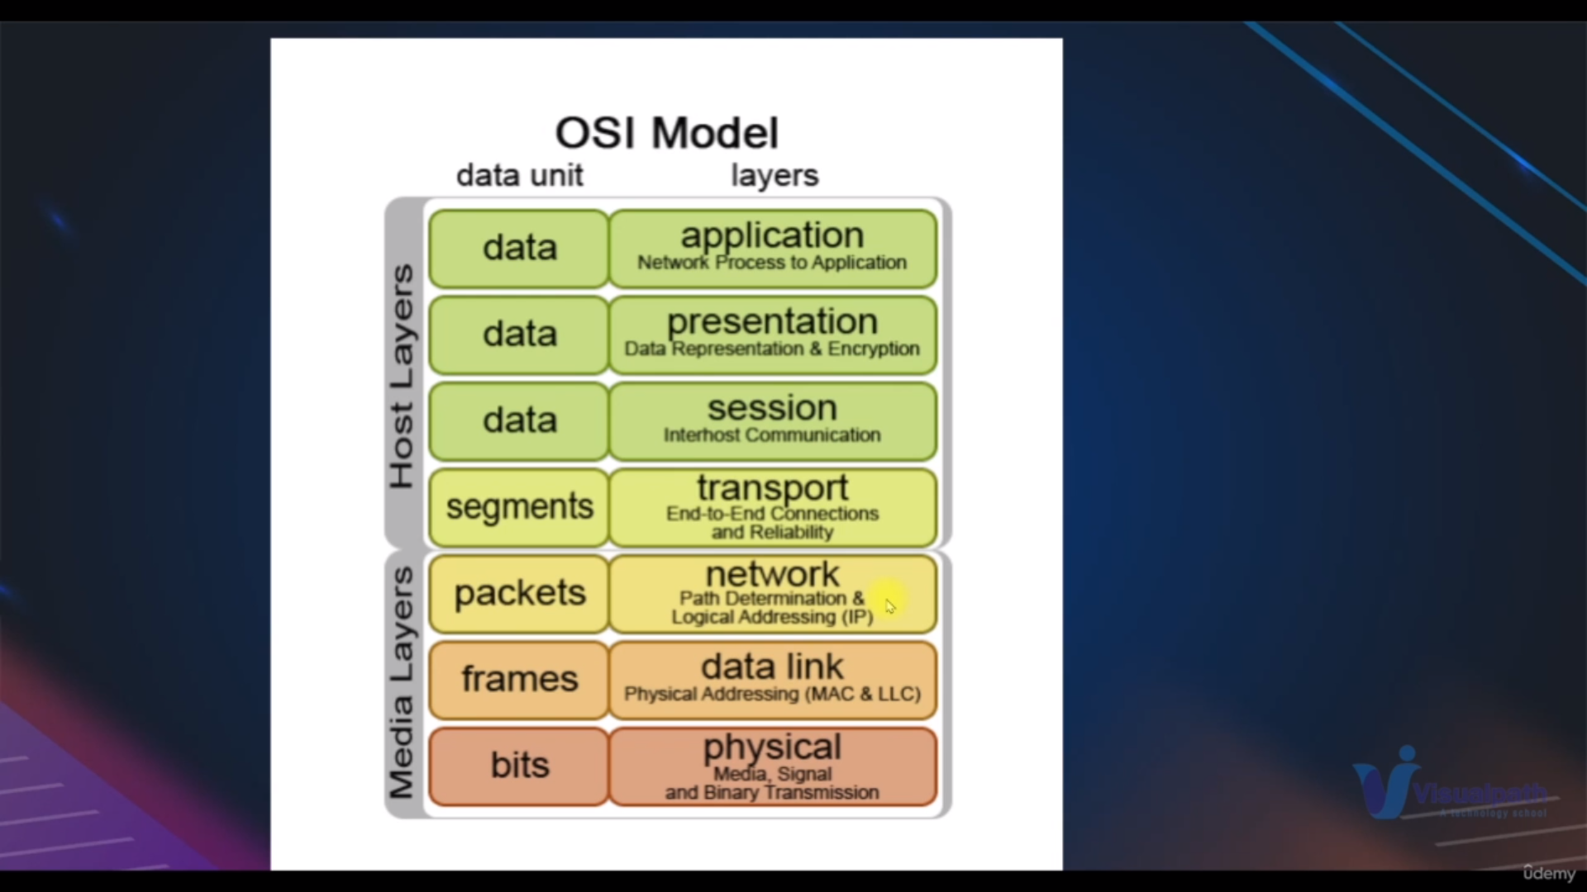Bits->frames->packets->segements->data(inabove three layers)

In bits we have zeros and ones

In frames we have mac adress

In packts we have ipadress

In segements along with ipaddress error recovery s/w

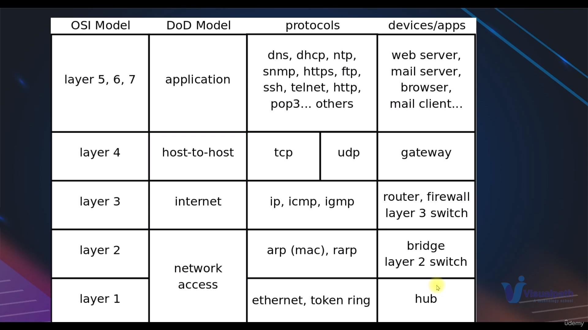

Device-> lancard-> switches->routers->gateway->mailservers->device

Bits->macaddress->logicaadress->tcp-ip protocols->mangesessions->encrpytanddecrpyt->userinterface 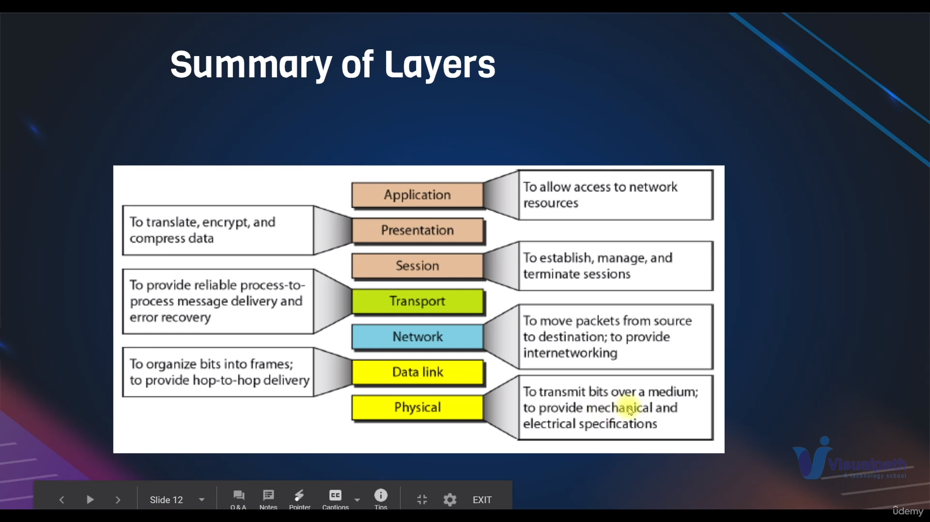

**Types of netwoks and ip:**

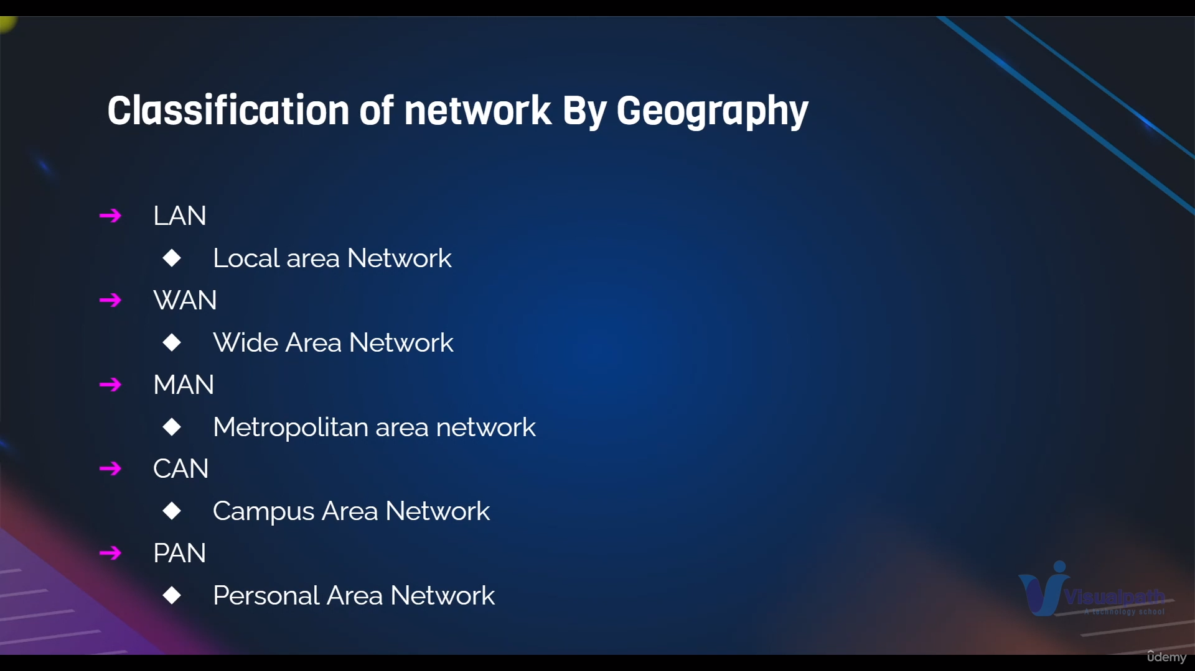

lan- local area network means which has multiple devices connected in same network using switches

ex: connecting our pc to printer

wan – In wide area network multiple switches or lan networks connected to routers for interent

ex: connecting our pc and mobile to router

pan- personal area network is the device connected one device

ex-connecting bluetooth buds to mobile

man: metropolitan area network which connects one city network

can : campus area network is similar like above n/w but it restricted for one campus

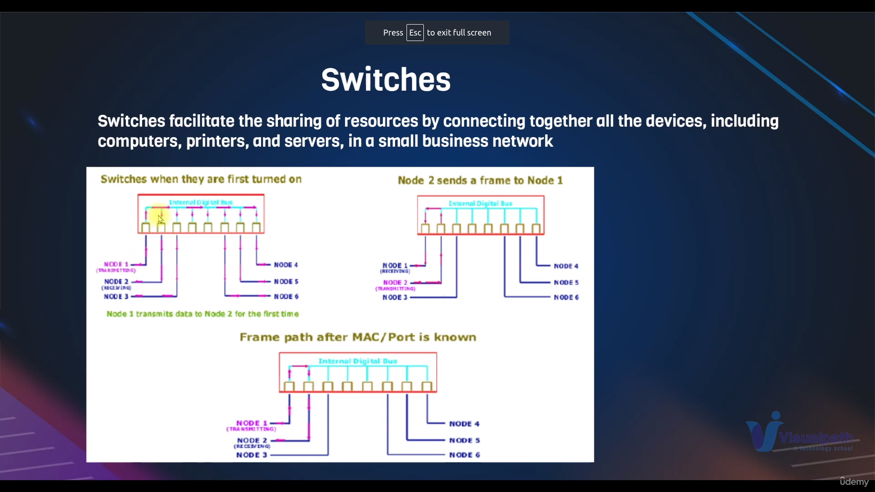switch used to connect two devices in same n/w

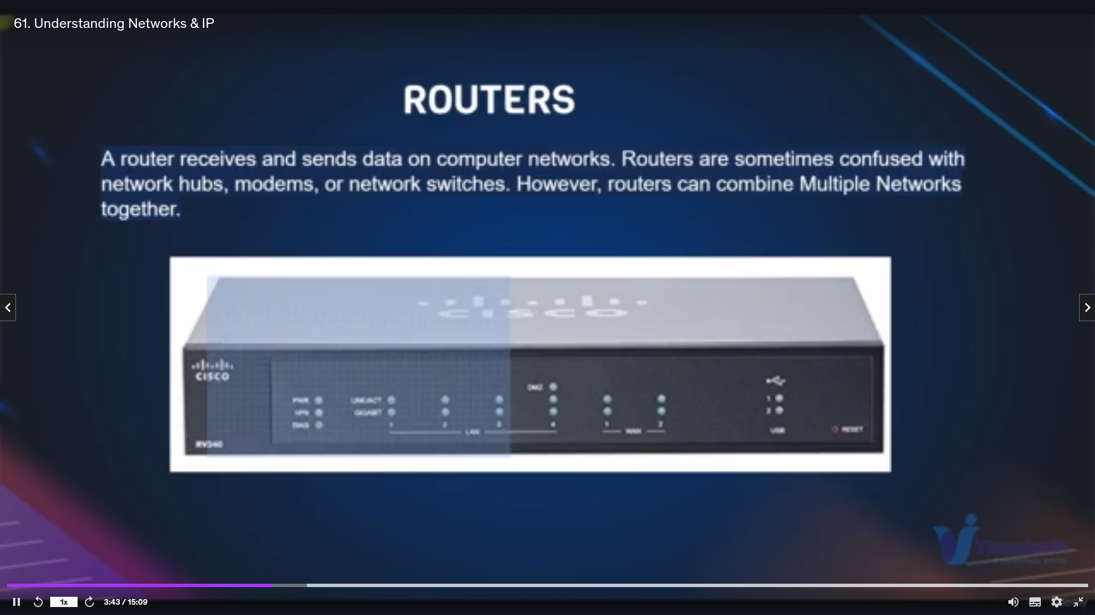router which two different n/w [or two different switches] to internet

some of the networks

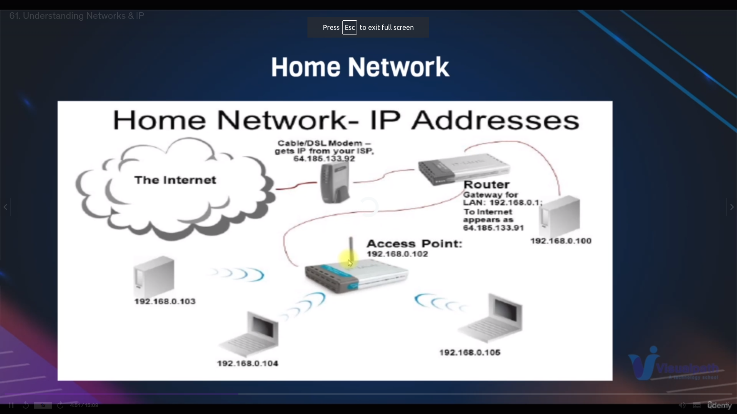

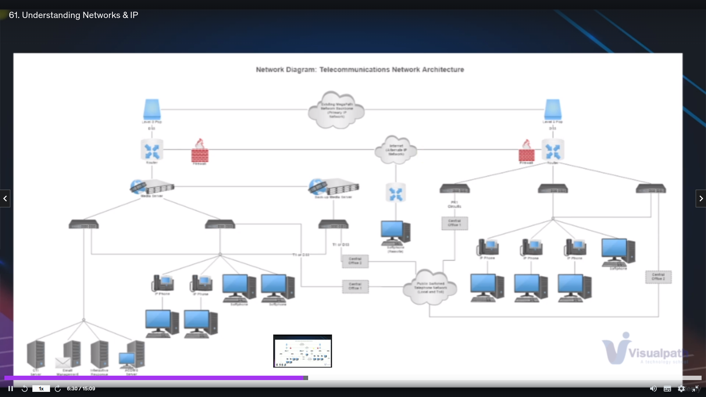

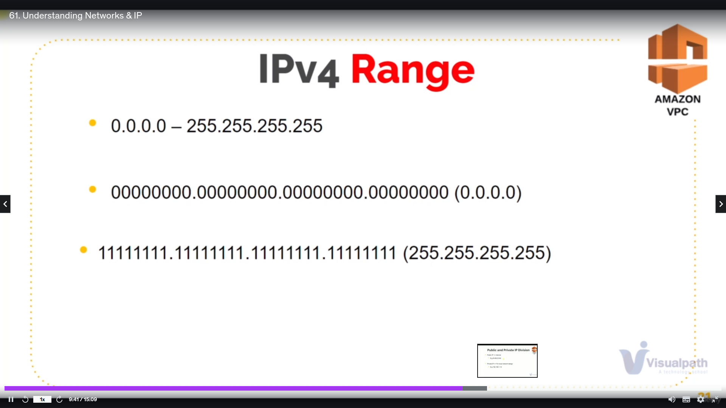

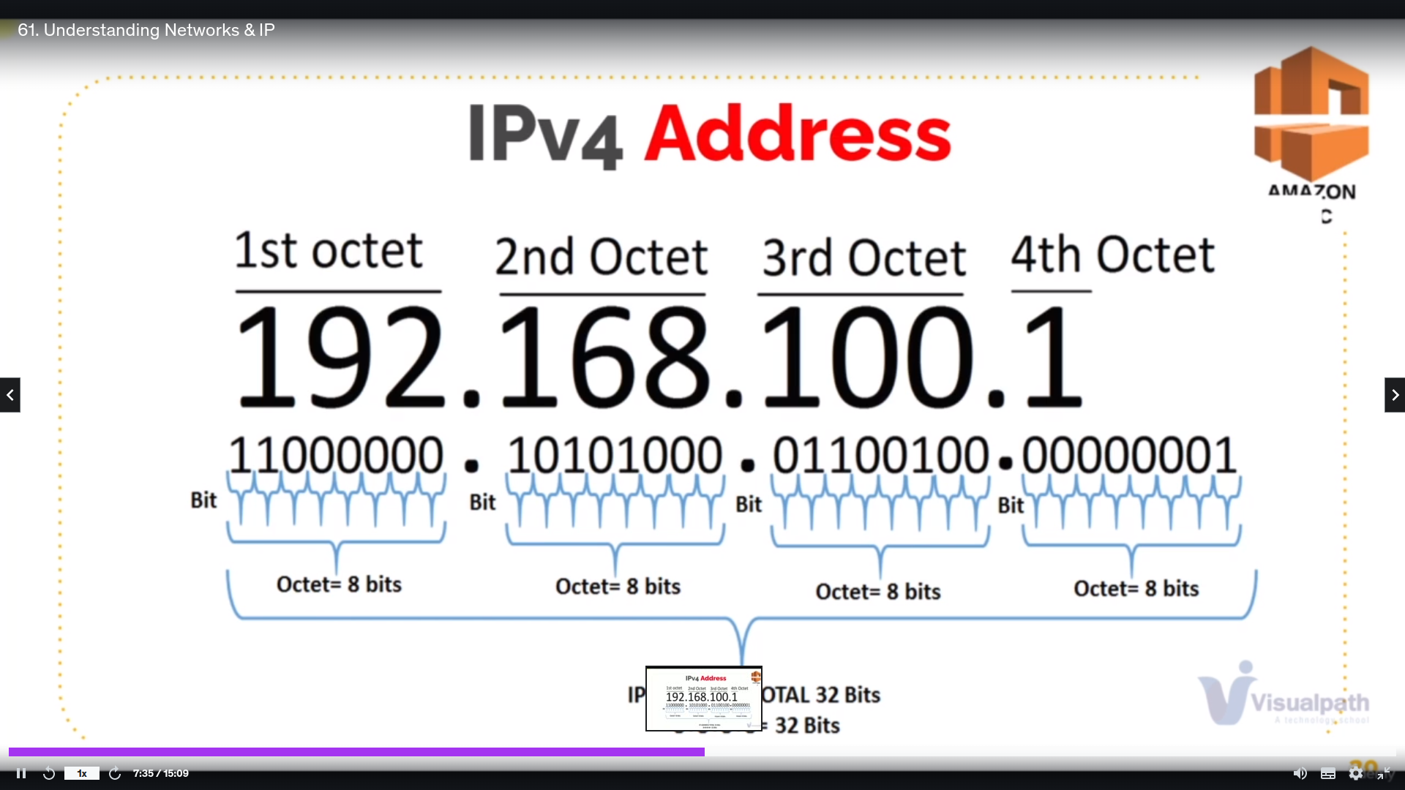we have ipadressing in binary form

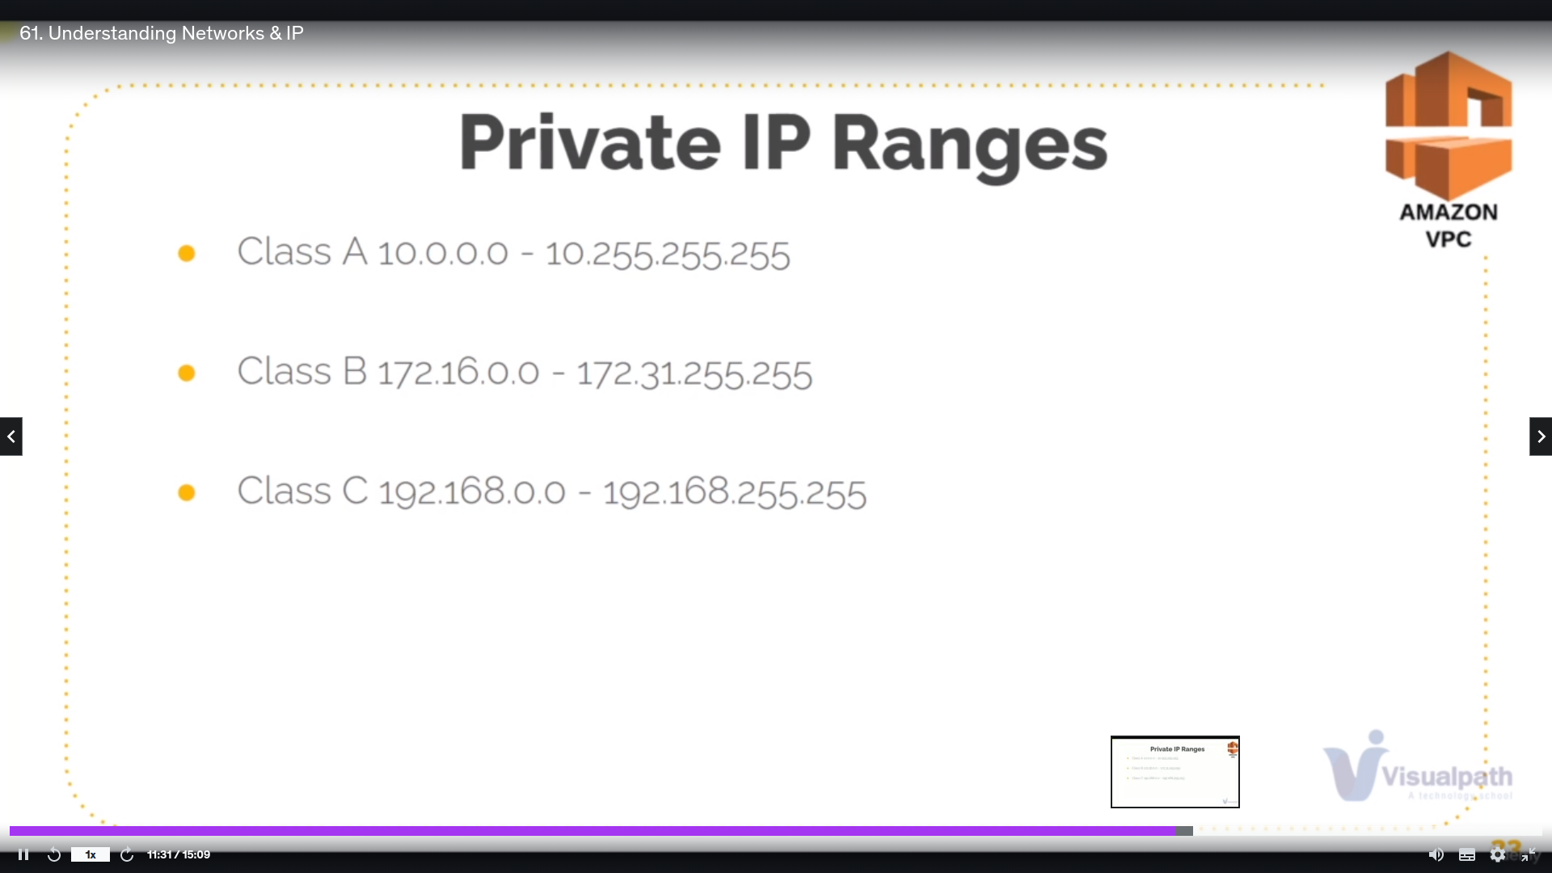

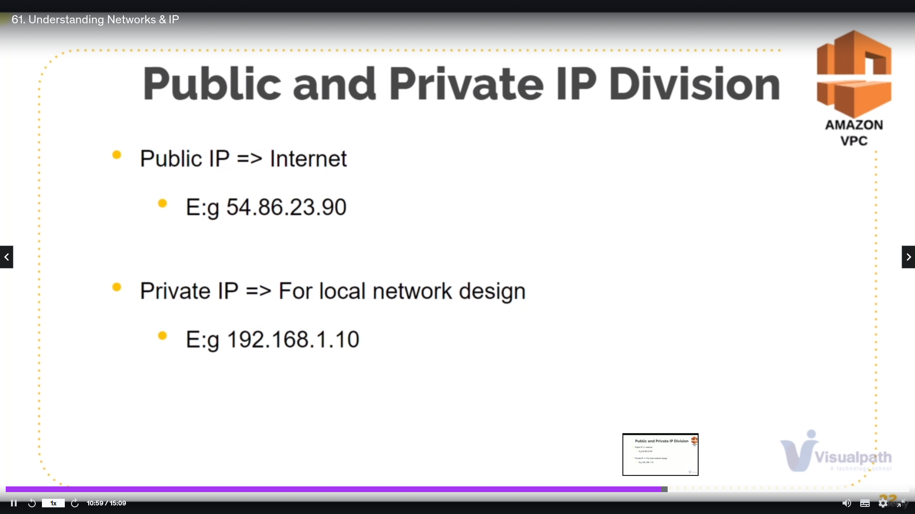examples of public and private ip’s

**Protocols:**

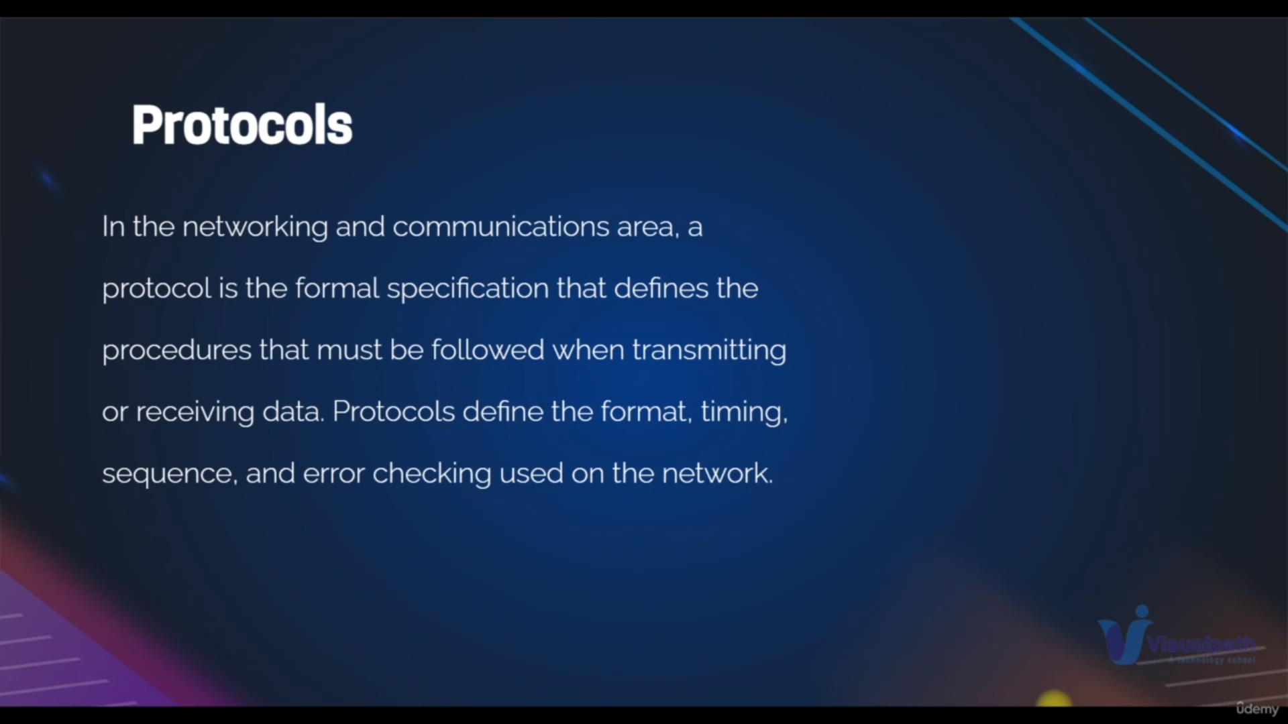protocols are the set of rules that used for secure transmission of data even after getting errors

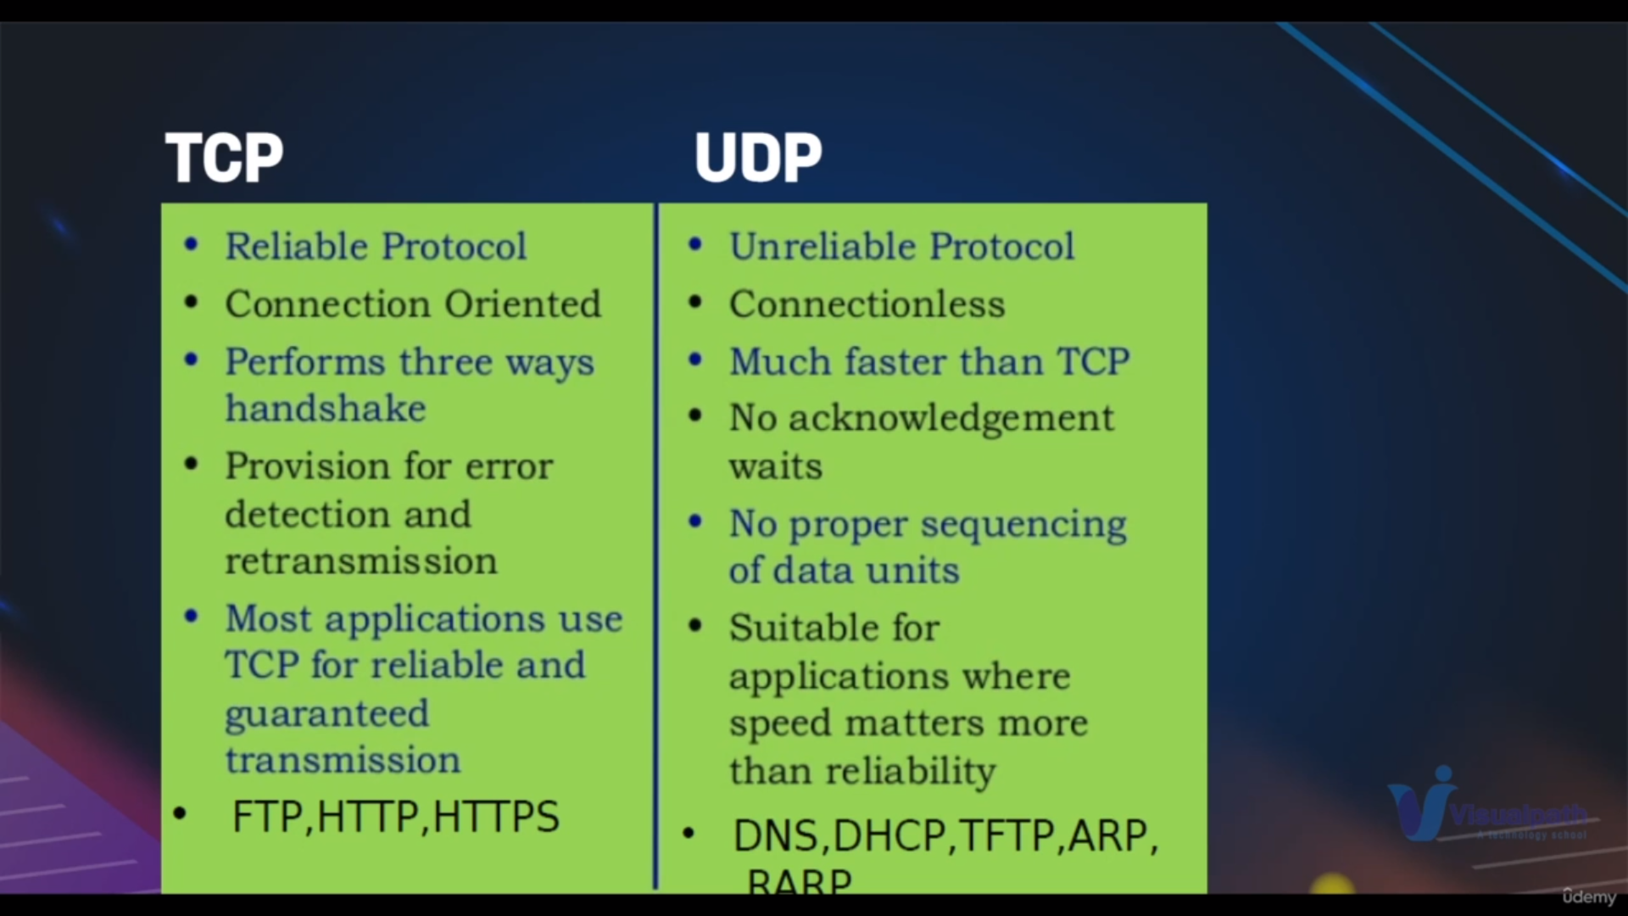if we need secure and sent data and received data should be same then use tcp

if we need faster communicatation use udp

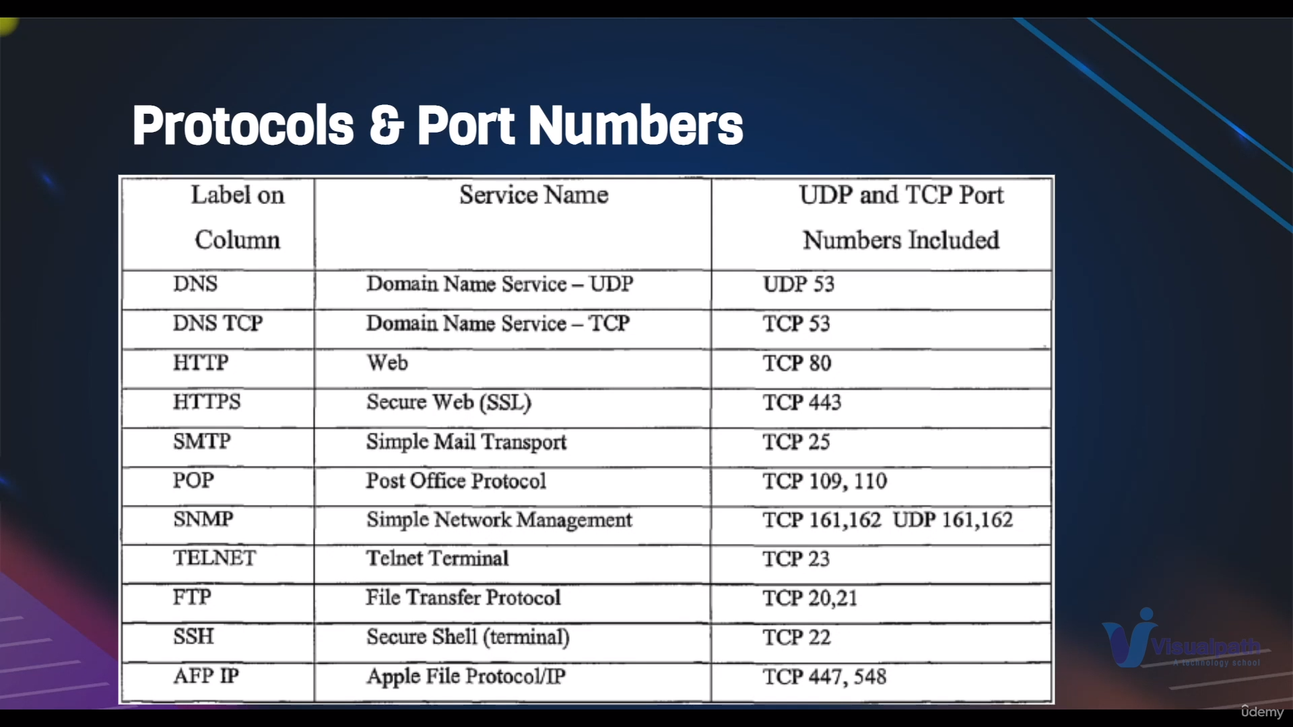Each port no serves for different function for example if we need to access webserver only through http protocol of port no 80 the communication is possible because that port no only has program how to handle the web communication data

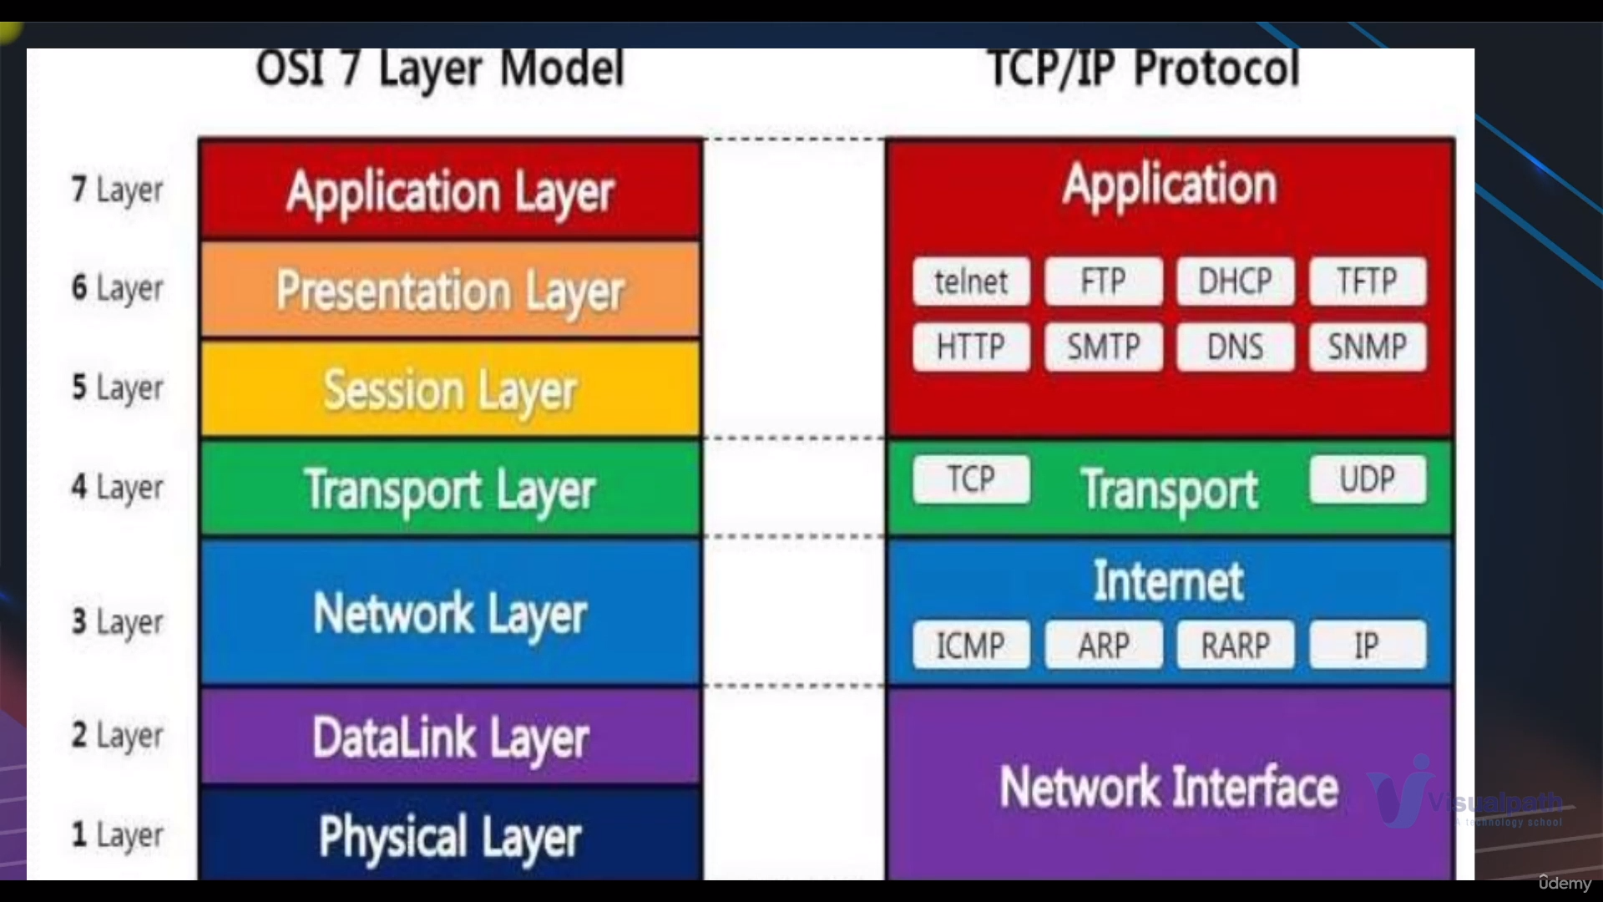in this we have which protocol is used in which layer

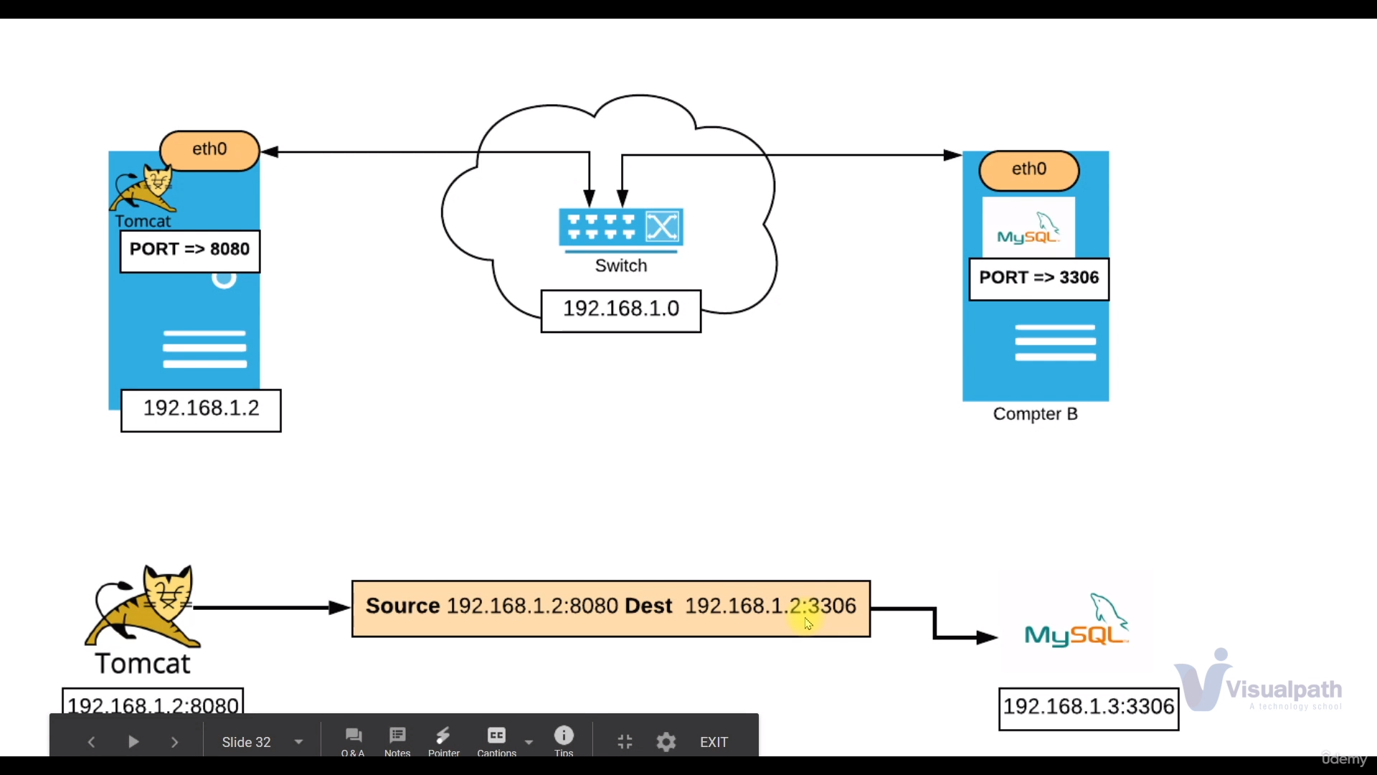In this the tomcat server which has the port 8080 has to communicating with the mysql server which has the port no 3306

the second image is showing the how the url look like when these two services are communicating

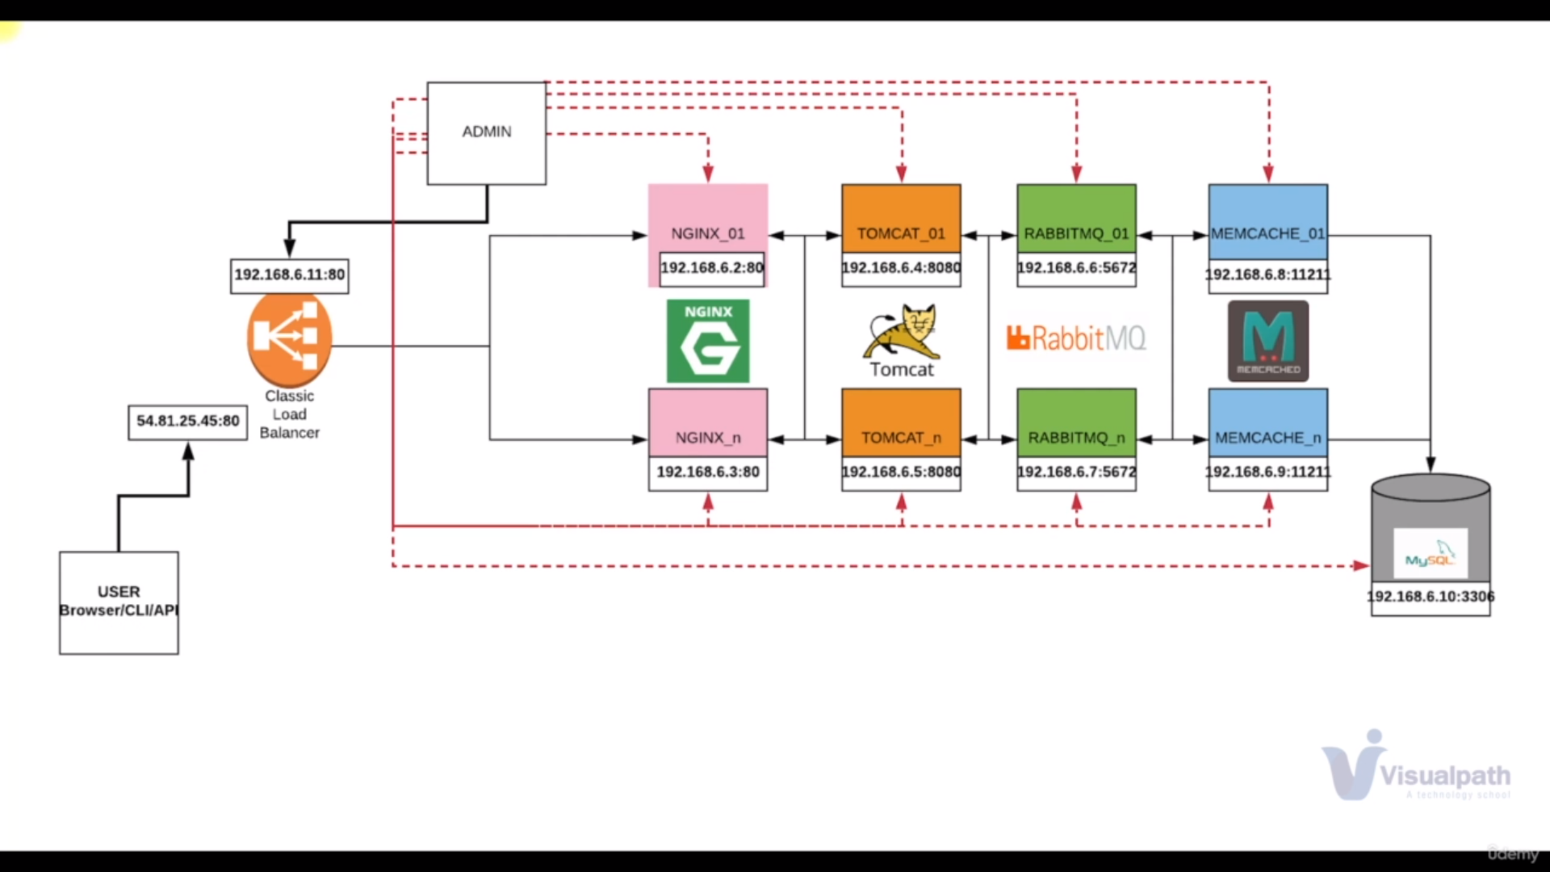image shows micro services which is having communication b/w them

**Networking Commands:**

**ifconfig**command used to show active network interfaces and ipadresses

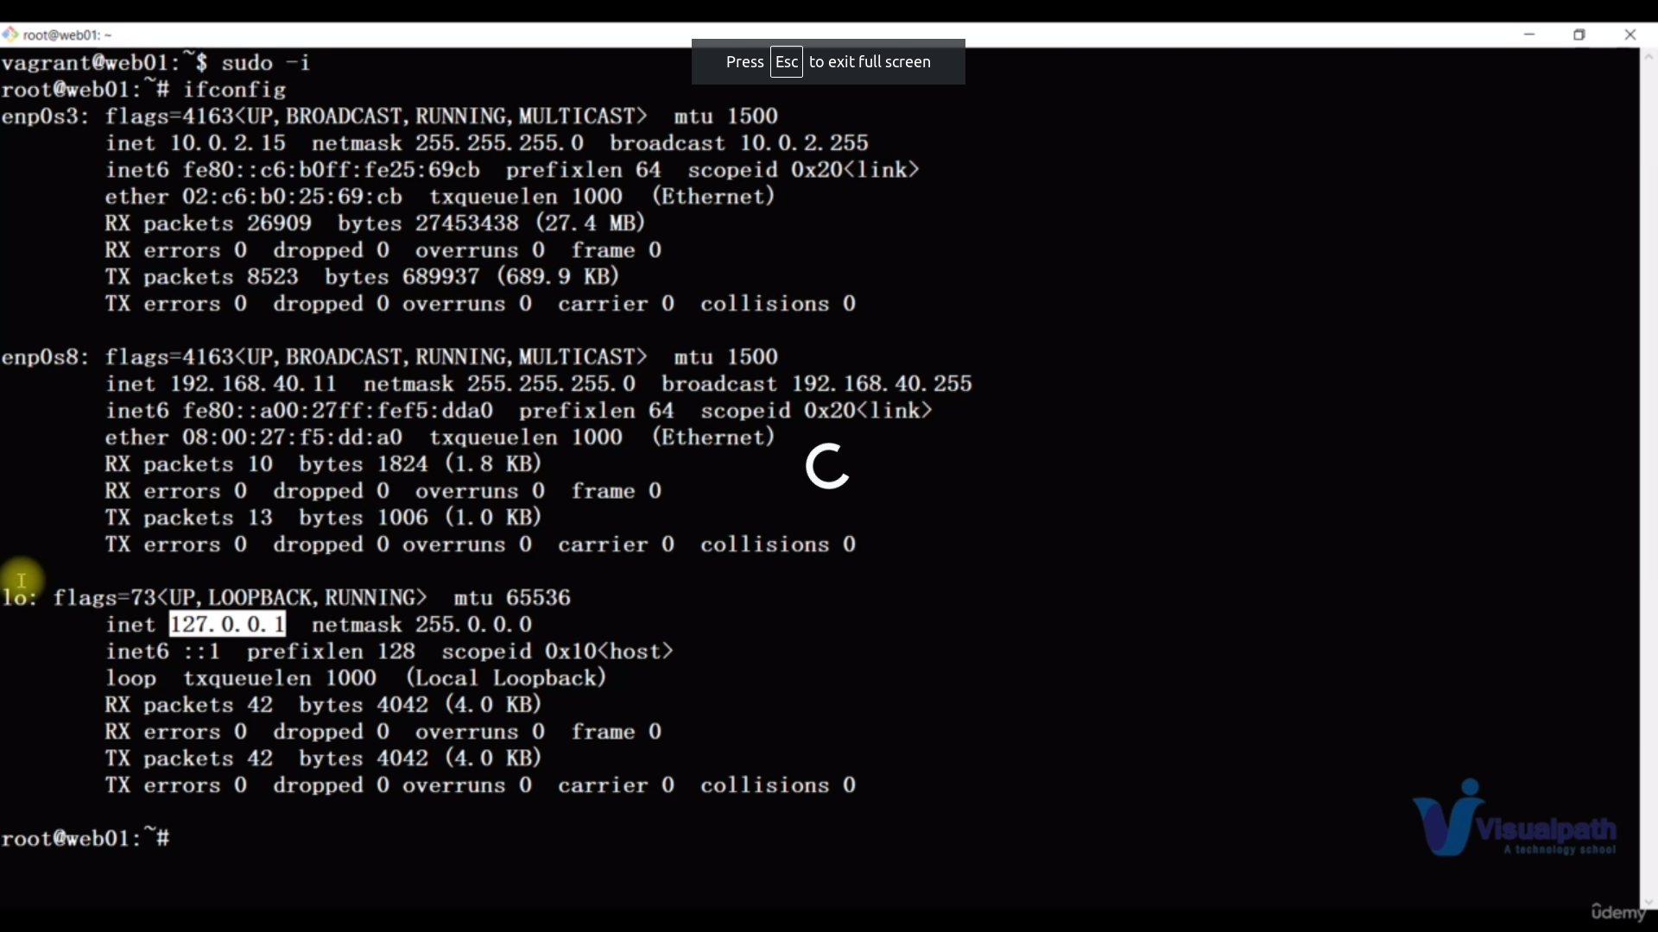here etp0s3 and epp0s8 are n/w interfaces with ipaddr 10.0.2.15 and 192.168.40.11

lo is also n/w interface but it loopback interfacel like it is for inside communication not for outside communication

**ping google.com**

it will send the packets to google that the communication is possible or not

in linux it continuously sents

in windows only four packert sents

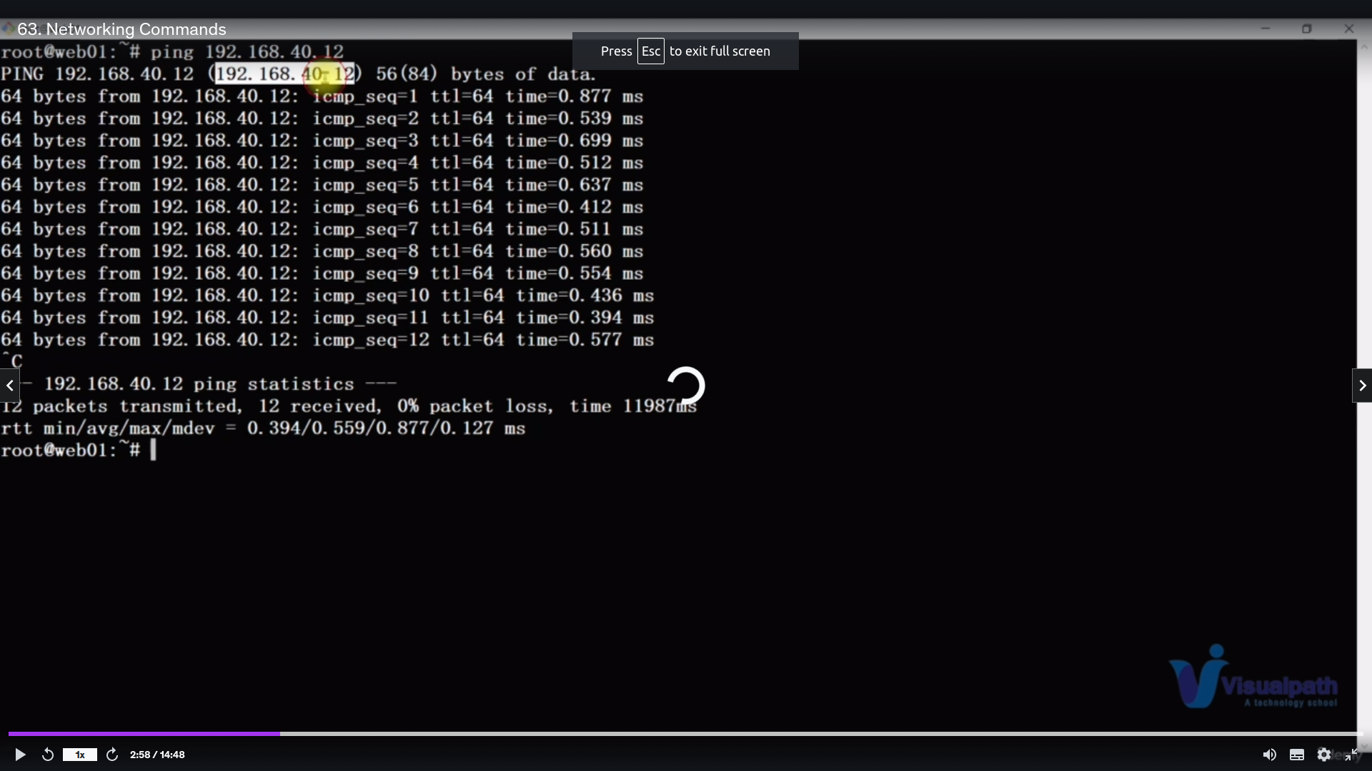in this image communication is much possible because 0%packets loss and all packets are receive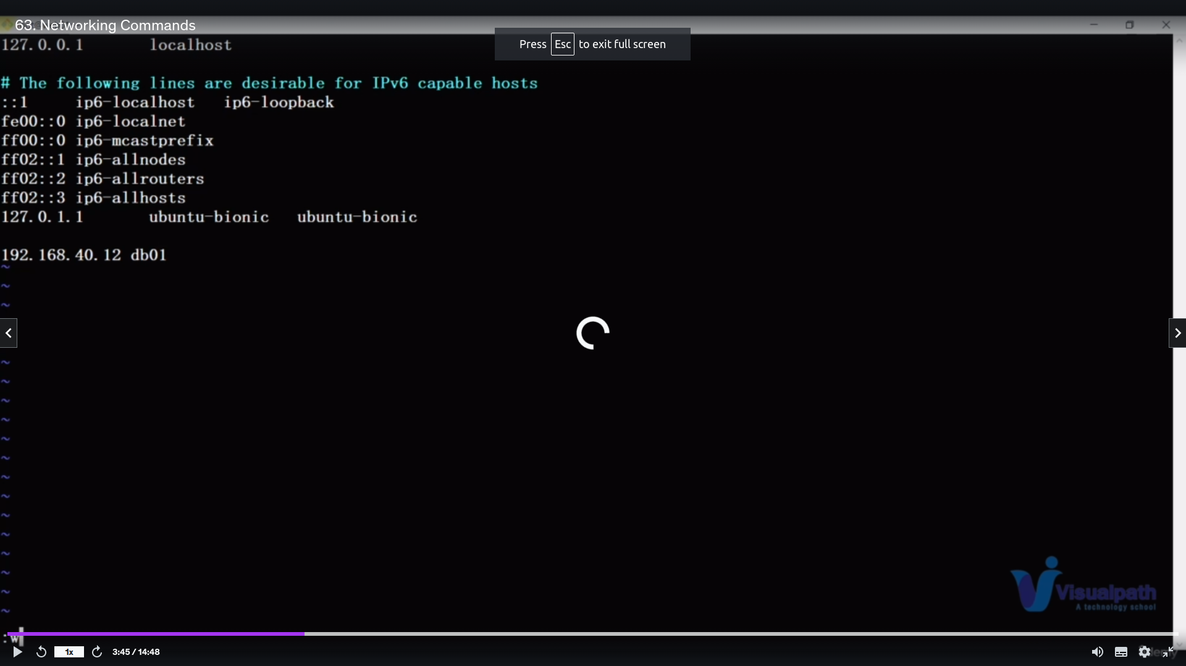d

if we want to communicate with specific device then edit the file***/*etc/hosts**

with

ipaddress hostname

like in the image

192.168.40.12 db01

**tracert www.google.in**

it is same like ping command it will show the complete path of the packet transmission

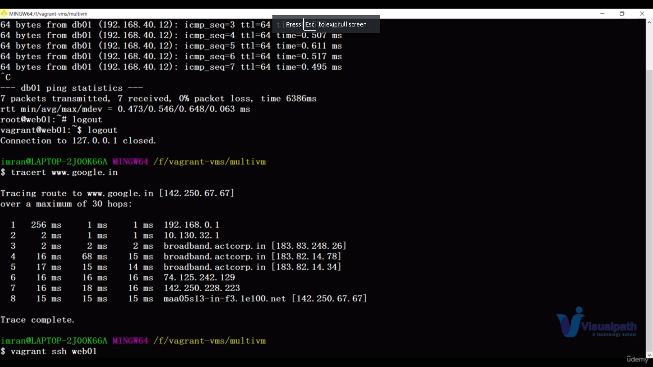

in this it shows how much miiiliseconds is transmisted b/w each ops or device or hubs or switches or routers upto it rechers google

in this we can get if any error occurs we can easily findout on which n/w device we got error

**netstat -antp , ss -tunip**

it shows all the tcp open ports in current devices with which process id opened which port

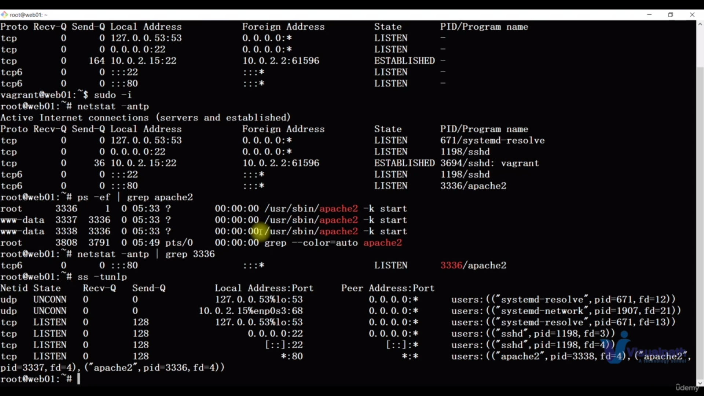ss -tunip is a new command

nmap is also a command which act like same but it is illegal in some countries and also we have to install it

**dig** [**www.google.com**](http://www.google.com/) **and nslookup** [**www.google.com**](http://www.google.com/)**:**

it will show the dns severer of the google so that the dns resolution of google is working or not from you computer

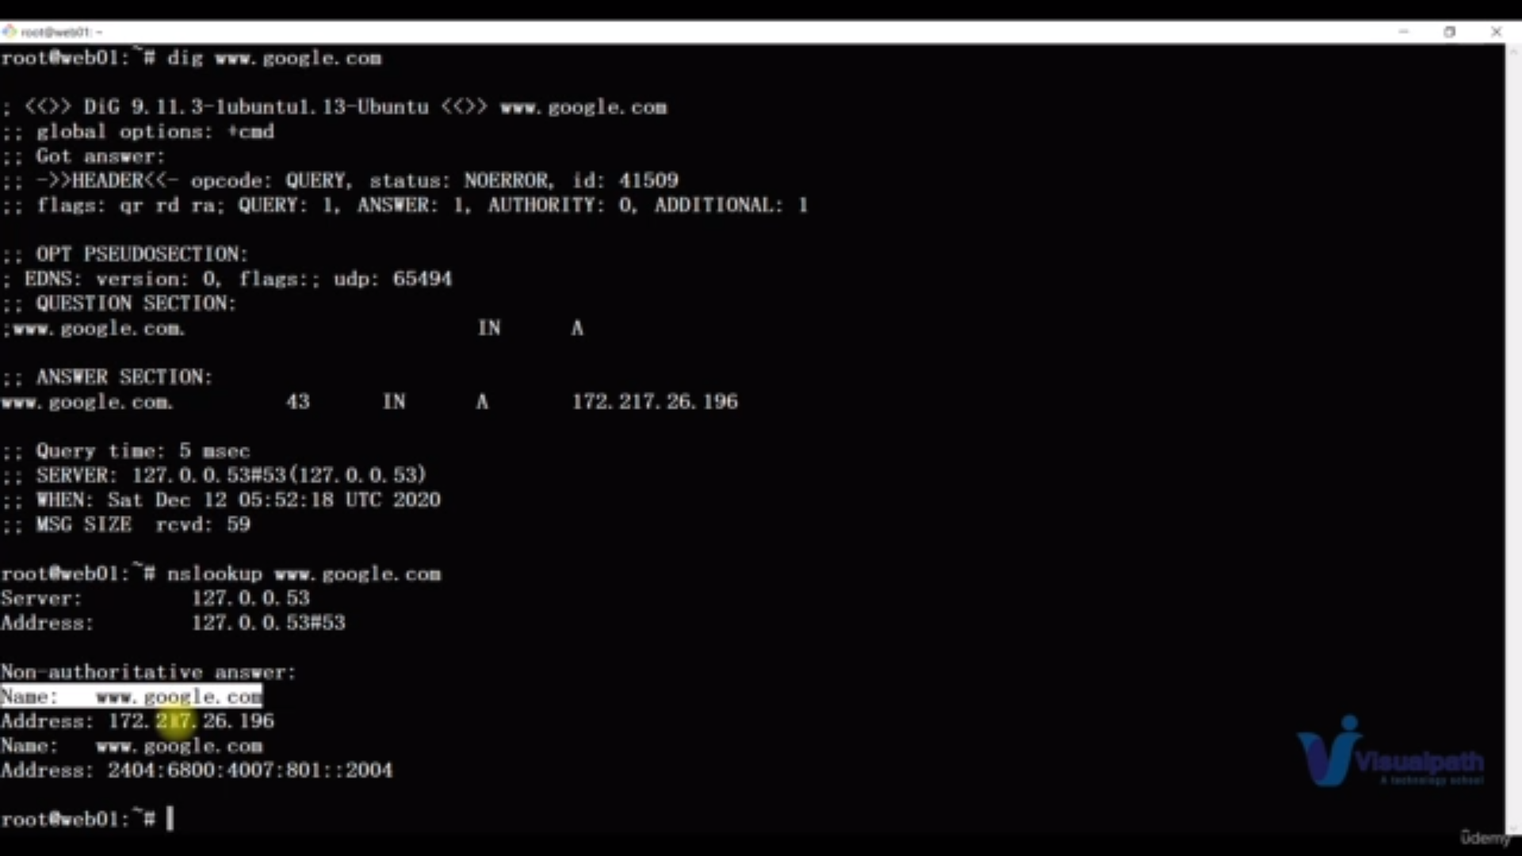nslookup is older version of dig command

**route**

it show all gateway of your computer

**arp :**

it show the kernal arp table which has the macadresses of systems

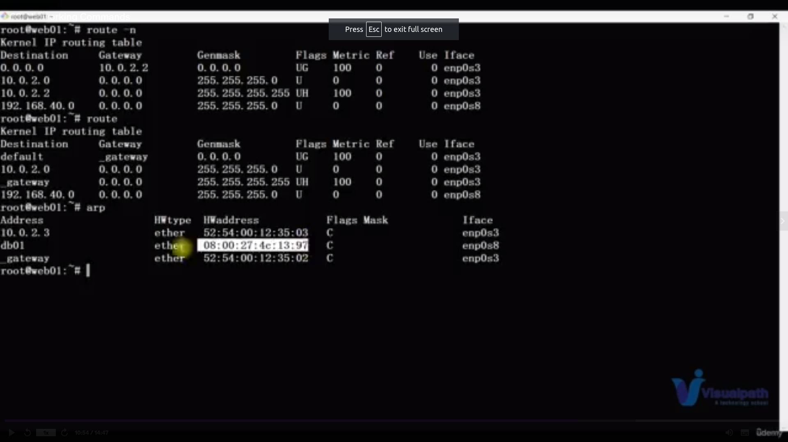

**mtr:**

it similar like traceroute[tracert command] but it is dynamic

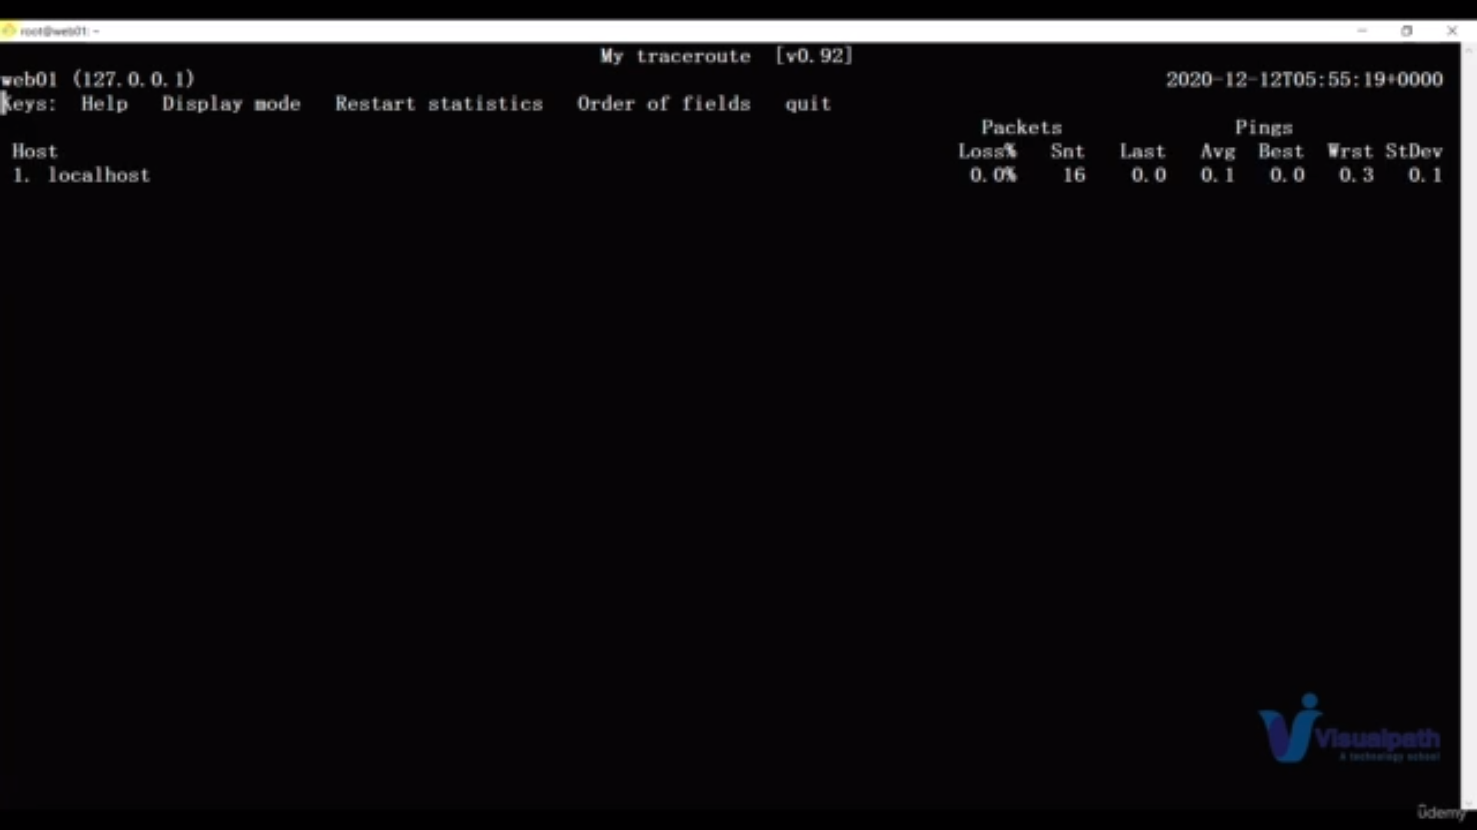

**telnet :**

it is used to whether our device is able to connect the other device services and also whether the port is open or not

